**Name of Student: Ramit Bose**

**Reg.No.: 21BCE1316**

**Ex. No: 06**

**Date : 10-03-2023**

**OO Design - Use Case Model. Class Model**

Aim: Creating Use Case Model and Class Model for my application ATM Management System using StarUML

Description:

Creating Actors like Customer, Technician and Bank; Use Cases like User Login, Check Balance, etc. and establishing suitable relations between them to carry out the proper functionality of the ATM Management system.

Output Screenshot:

USE Case Diagram:

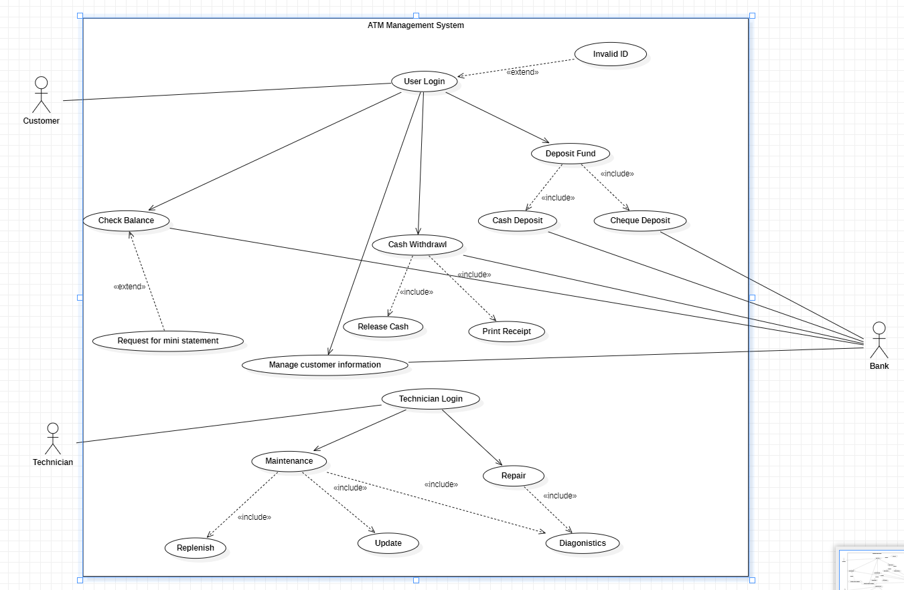

Class Diagram:

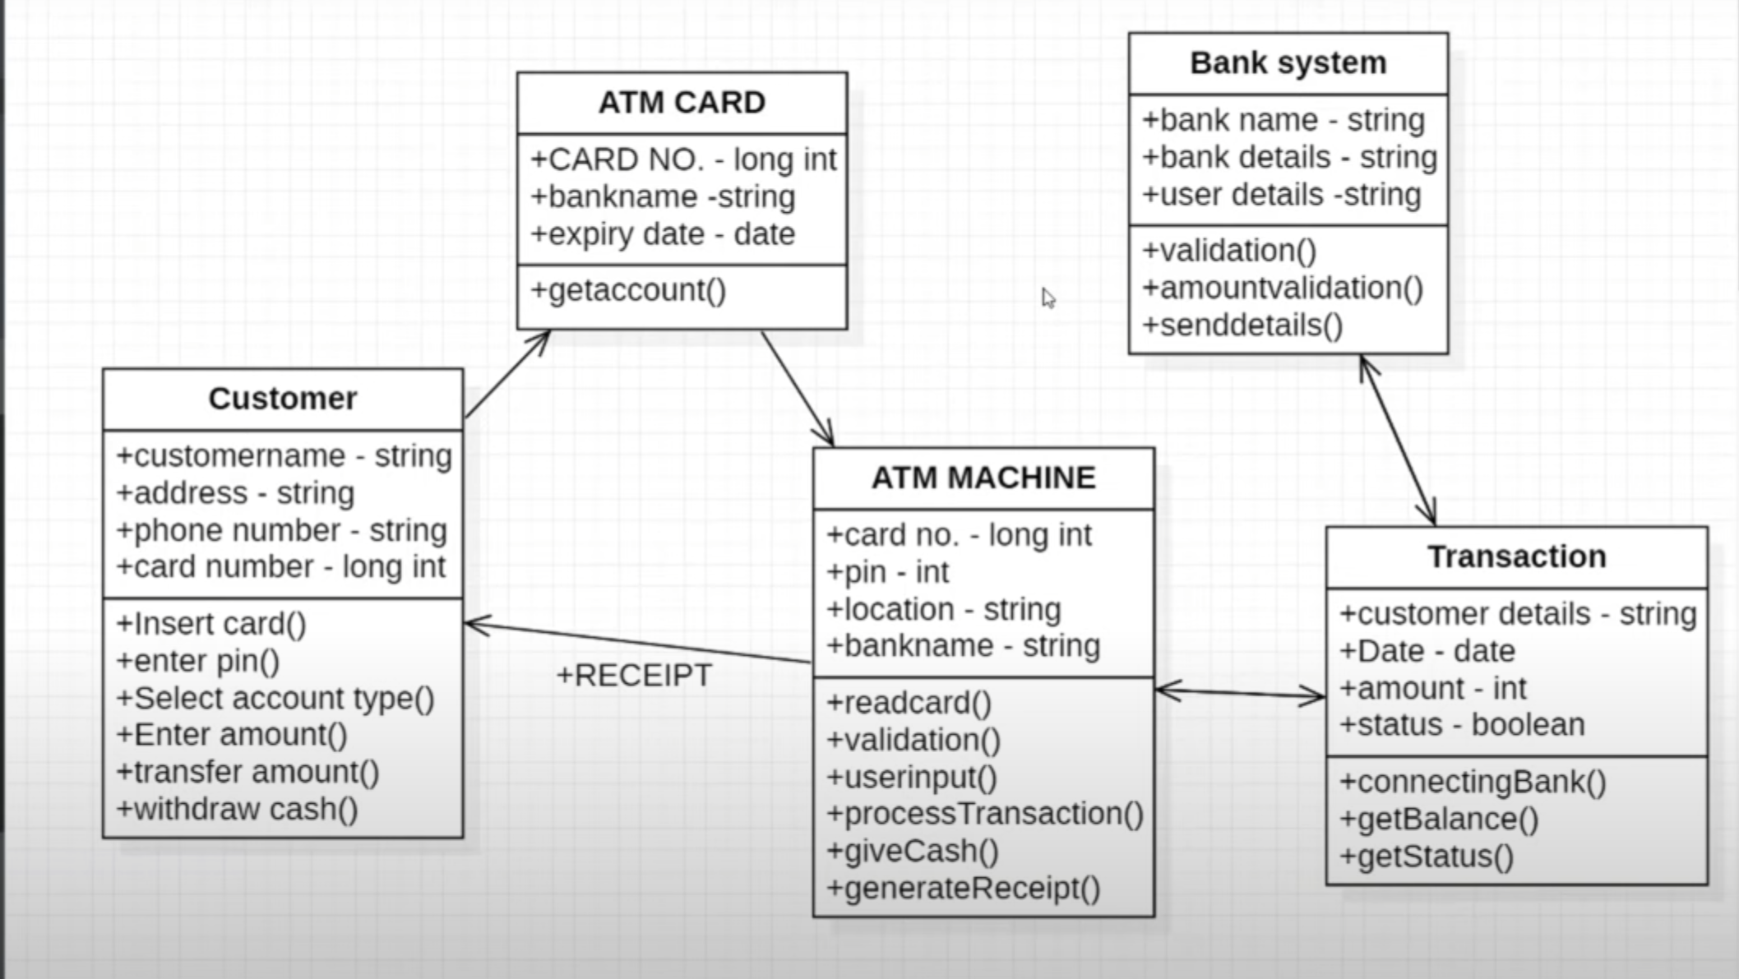

Result: The Diagram has been verified as successful by the lab faculty in-charge.